Positive Relationship
and Behaviour Policy

Updated September 2023

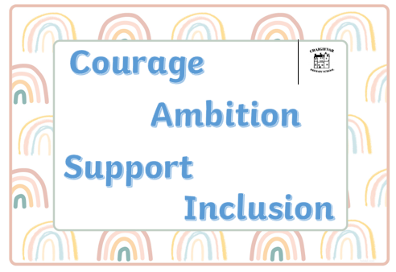

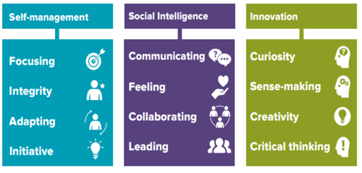

Better Relationships, Better Learning, Better Behaviour

“Developing good relationships and positive behaviour in the classroom, playground and wider community is essential for creating the right environment for effective learning and teaching. Where children and young people feel included, respected, safe and secure and when their achievements and contributions are valued and celebrated, they are more likely to develop self-confidence, resilience and positive views about themselves.”
Scottish Government 2013

Dear Parent/Carer,

This policy outlines how Craigievar School aims to:

- educate the whole child and develop their personal and social skills to ensure their own wellbeing and that of others

- provide safe and stimulating learning environments for all children and young people enabling them to reach their full potential and become successful learners, effective contributors, responsible citizens and confident individuals

- ensure children and young people have regular opportunities to develop an understanding of their rights and responsibilities

- develop a desire in our pupils, families and staff to make a positive contribution to their community and wider world

- Recognise and develop positive qualities in themselves and others including leadership capacity and skills for life, learning and work

This policy has been developed in consultation with pupils, families and staff. As with all our practice, the successful implementation of the policy is dependent on a successful and supportive relationship with parents, carers, pupils and staff. This policy will be reviewed regularly and amended in response to feedback and consultation. This will ensure positive outcomes for all.

If you have any questions or comments regarding this document, please do not hesitate to get in touch.

Kind Regards,

Lindsey McBride
Head Teacher

Relationships are central to positive behaviour
Craigievar School is a small school where all staff are committed to fostering an ethos which promotes relationships built on mutual trust and respect. We work hard to create an engaging and empowering climate for learning where each member of our school community feels valued and that they belong.
All members of the school community ensure our core values; courage, ambition, support and inclusion, underpin our day to day conduct.
Across the school community we strive to ensure relationships are supportive. There is a strong sense of community with shared values and high expectations. Our nurturing and inclusive practice supports a restorative approach to building relationships, encouraging positive behaviour and developing skills associated with social intelligence i.e. communication, emotional literacy and self-awareness.
All staff understand and accept that the responsibility for promoting positive relationships with children lies with them. Staff are expected to demonstrate high standards of professional conduct as outlined in the GTC Standards for Registration.
Through supporting the development of emotional literacy we aim to support our young people in understanding, managing and regulating their emotions. The support may look different for each pupil as we consider their individual strengths, needs and characters. Our restorative approach enables our pupils to reflect on challenges and mistakes, identify triggers and regulation strategies and consider what can be done to repair any harm caused. This helps all involved to move forward in a positive manner.
In line with ‘Getting It Right For Every Child’, this policy is underpinned by the United Nations Convention on the Rights of the Child and wellbeing indicators. All members of staff at Craigievar School will reinforce and celebrate positive behaviour by modelling rights respecting behaviours, actions and language.
There is an expectation that all members of the school community will also model these behaviours. We politely request that parents and family members demonstrate a supportive attitude towards school and school staff – this has a hugely positive impact on our pupils’ understanding that we are partners in their wellbeing and education. Staff will always make every effort to discuss any concerns or feedback with parents privately at a mutually agreeable time.

The Role of School Staff

Relationships and communication between all adults and children should be respectful and supportive. They should reflect the underlying principles of nurture and restorative practice (see below).

Staff are responsible for:

- Promoting and upholding the Positive Relationship and Behaviour Policy;
- Supporting an ethos where children feel safe, secure and valued and where positive relationships are seen as fundamental;
- Establishing open, positive, supporting relationships across the community
- Engaging with partners (e.g. Educational Psychology) and undertaking high quality Career Long Professional Development in order to plan and deliver effective supports and interventions for children who have been identified as requiring additional social and emotional support.
- Monitoring (and recording where necessary) incidences of negative behaviours and supporting children, staff and families in minimising reoccurrences of these behaviours;
- Setting high expectations of all children;
- Following restorative approaches to ensure a consistency and fairness
- Providing a rich, stimulating, varied and challenging curriculum and teaching methodologies which foster high levels of pupil engagement;
- Listening to children and all members of the school community and taking appropriate action;
- Being sensitive and responsive to the wellbeing of each child and young person, taking account of individual needs
- Embedding the 6 nurture principles across all aspects of school life:

  - Children’s learning is understood developmentally
  - The classroom offers a safe base
  - The importance of nurture in the development of wellbeing
  - Language is a vital means of communication
  - All behaviour is communication
  - The importance of transition in children’s lives.

The Role of Parent/Carer

- To promote and uphold the Positive Relationships and Behaviour Policy;
- To respect the professionalism, knowledge and experience of school staff, trusting that this policy will be followed by all
- To ensure school staff are aware of any additional needs or personal circumstances that may impact the young person’s health, wellbeing and/or capacity for learning
- To support the development of our core values through positive partnerships
- To alert staff to any concerns or questions which arise in an appropriate and timely manner
- Parents/carers are expected to discuss all concerns regarding their child/children with a member of staff and trust that the matter will be investigated, addressed and appropriate action taken as per this policy
- To work in partnership with the school to ensure all children have the opportunity to thrive

Getting It Right For Every Child

This policy outlines our standard procedures for supporting children. However, each child is an individual. An increasing number of children and young people in Aberdeenshire's schools have an identified Additional Support Need (ASN), with the figure approaching around half of all pupils. It is, therefore, essential that approaches, strategies and consequences must be differentiated where necessary in order to be effective.
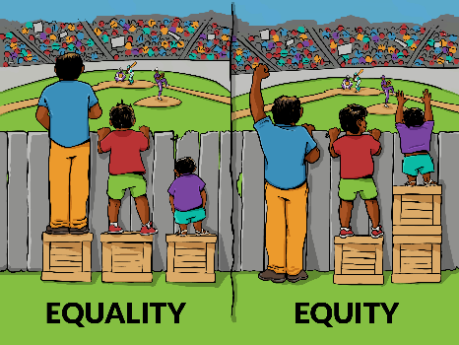

At Craigievar School, each child is treated as an individual and with respect. There may be individual pupils for whom the procedures outlined here are not effective for a variety of reasons. It is important to understand that many children have additional support needs where their behaviour is affected by particular difficulties/challenges. Specific and tailored supports and strategies are carefully planned to meet individual needs.

Restorative Practice

Restorative discussions are key to promoting positive relationships and behaviours. These discussions help children to recognise the impact of their words/actions and identify ways to resolve conflict and/or repair harm. Restorative discussions and approaches support pupils by helping them talk about their thoughts and feelings, identify triggers, to reflect on their words/actions. These discussions can involve the child/children who have been affected by negative behaviours if they are comfortable in doing so. Staff will guide restorative conversations between children (using visuals if appropriate) resulting in positive outcomes for all. Restorative discussions will only take place when all parties are calm and emotionally able to engage with the process effectively.

Example questions we may ask during a restorative discussion:

1. What happened? What was the ‘trigger’?
2. What were you thinking/feeling at the time? What are you thinking/feeling now?
3. How do you think it made _______ (name) feel?
4. How would you feel if it happened to you?
5. What could have been done differently?
6. What do you think you need to do to repair the harm/to put things right?
7. What regulation strategy could you use?

Encouraging, Recognising and Celebrating Positive Behaviour

We know that the best way to encourage positive behaviour is to recognise and celebrate ‘the good!’ We utilise a wide range of strategies and methods to recognise and celebrate demonstration of our core values and other associated attitudes and behaviours (e.g. effort, resilience and kindness. These methods include (but are not limited to):

- Non-verbal rewards - a smile, demonstrating pride, high five etc
- Verbal praise
- Celebrating work, effort and kindness by informing and sharing with others
- Stickers
- Notes/letters/emails to parents/carers
- Celebrating effort and achievement at assemblies, on social media and in newsletters;
- Individual ‘Celebration of Learning’ displays
- Awarding ‘Punches’ on child’s punch card leading to a Golden Ticket (see below)
- Collective class rewards when ten Punch Cards have been awarded
- ‘Golden Moment’ Stickers to highlight positive moments
- Opportunities to adopt leadership roles and positions of responsibility such as running a lunchtime club, being a Play Leader or Literacy Leader, Lunchtime Assistant
- ‘Recognition Treat’ – a one off recognition for those consistently displaying our core values

Punch Cards

Each child has a ‘Punch Card’ on which they collect ‘punches’ (shown below). Punches are awarded in recognition of displaying school values and associated positive behaviour. Once a child has filled their card by earning ten ‘punches’, they receive a Golden Ticket which can be exchanged for a reward of their choice. Every time ten Punch Cards have been filled, the whole class receive a reward e.g. a movie afternoon, bring a toy from home. Again, the rewards are decided by the class and class teacher and will vary from class to class.
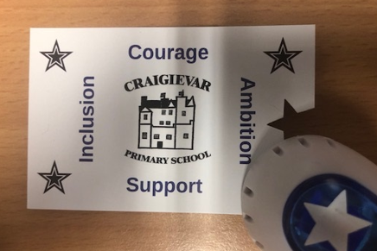

Consequences

The UNCRC states that “Discipline in schools should respect children’s human dignity” with Article 37 stating that, “Children should not be punished in a cruel or hurtful way.” In order to protect the rights of our children, we believe it is important to outline a clear strategy for instances where consequences are appropriate in encouraging positive choices and behaviours. Through the sharing of clear boundaries and through focus on celebrating positive behaviour, all members of the school community should have a sound understanding of expectations, the processes and procedures followed by school staff and any consequences resulting from negative, undesirable or inappropriate behaviours.

The following system has been agreed:

Stage 1 – First verbal and visual reminder
The negative action/words/behaviour will be identified e.g. Can you stop and reflect please? Are you being supportive of others? The child will be shown our ‘Stop and Reflect’ visual as a prompt to reflect on our core values.

Stage 2 – Second verbal and visual reminder
If the actions/words/behaviour persists, the process above will be repeated. The child will be reminded that this is a second reminder and consequences may be applied if a third reminded needs to be given.

Stage 3 – Appropriate consequence/s applied
If the actions/words/behaviours continue, proportionate consequences will be applied (see below). Parents/carers will not usually be informed of ‘one-off’ instances where minor consequences have been applied e.g. a child is excluded from the playground for 5 minutes.

Stage 4 – Parent/Carer discussion
If stages 1-3 have been, or are being, actioned regularly and the process has not been effective in promoting positive behaviour, parents/carers will be contacted in order to adapt or identify supports and strategies that will meet the needs of the child and result in more positive outcomes for all. This discussion can take place via e-mail or telephone.

Stage 5 – Consultation Meeting
If the amended strategies/supports do not result in improvement, an in-person consultation meeting will be held. The meeting will involve school staff, parents/carers and, where appropriate, the child. The purpose of this meeting is to discuss any factors that may be impacting the child’s capacity for improvement and to identify steps that can be taken to make a positive impact on learning and behaviour. This may include identifying partner agencies/other professionals that may support or identifying a pathway in line with Aberdeenshire ASN/GIRFEC policy.

Examples of Appropriate Consequences

- Discussion with Head Teacher
- Restorative measures such as writing a letter of apology, repairing damaged property
- Exclusion from playground for all/part of break periods
- Loss of privileges e.g. access to football pitch, access to device, attendance at a club/activity
- Completion of learning task during break period or at home

Serious/Significant Incidents

If a particular incident is judged to be more serious or significant, the following procedure is in place:
- A full investigation will be carried out.
- Parents/carers of all parties involved will be contacted immediately and a consultation meeting arranged
- Details of the incident will be recorded in the appropriate manner and support/restorative measures put in place
- Appropriate consequences/supports planned and implemented
- Arrangements for monitoring identified – this may include risk-assessment

Consequences for serious/significant incidents may include:
- Immediate internal exclusion (child withdrawn from class/playground for a period of time)
- External exclusion (temporary exclusion from school)
- Permanent exclusion

Exclusion: 2.1 Legal Context

If all other interventions are evidenced as have been exhausted, exclusion may be an appropriate intervention to support learning and wellbeing with the aim of improving outcomes.

Under Regulation 4 and 4A of the Schools General (Scotland) Regulations 1975 (as amended), it is the education authority which has the power to exclude children from school. The Education (Scotland) Act 1980 places a duty on education authorities to make appropriate education provision when a child or young person is excluded. These powers (to exclude and make appropriate provision during exclusion) can be devolved by education authorities to senior management within a school. Regulation 4 and 4A provides that an education authority shall not exclude a child or young person from school unless the authority:

- “…is of the opinion that the parent/carer of the pupil refuses or fails to comply, or to allow the pupil to comply, with the rules, regulations, or disciplinary requirements of the school”; or

- “…considers that in all the circumstances to allow the pupil to continue attendance at the school would be likely to be seriously detrimental to order and discipline in the school or the educational well-being of the pupils there.”

Excluding a child or young person for any other reason/purpose has no legal basis.
(Revised Management Circular No. 8, August 2018.).

Anti-Bullying

Bullying in any form is intolerable and unacceptable. Parents/carers, pupils and teachers have a responsibility to work in partnership to maintain a high standard of behaviour and an environment free from bullying behaviour.

Please refer to our updated Anti-Bullying policy and Child-friendly Anti-Bullying Policy for more information.

Useful Policy Links

Anti-Bullying Policy for Learning Establishments (Aberdeenshire Council)
Anti Bullying Policy and Guidance (aberdeenshire.gov.uk)

Exclusion Policy (Aberdeenshire Council)
Promoting-Inclusion-and-Reducing-Exclusions-in-Educational-Establishments-Policy-2022.pdf (asn-aberdeenshire.org)

Better Relationships, Better Learning, better Behaviour (Scottish Government)
https://education.gov.scot/parentzone/Documents/BetterRelationships.pdf

Included, Engaged and Involved: A Positive Approach to Preventing and Managing School Exclusions (Scottish Government)
Included, engaged and involved part 1: promoting and managing school attendance - gov.scot (www.gov.scot)
Included, engaged and involved part 2: preventing and managing school exclusions - gov.scot (www.gov.scot)

Getting in Right for Every Child (Scottish Government) https://www.gov.scot/policies/girfec/

Policy Review

Evaluation of this policy will focus on the impact on all members of the school community.
Impact may be measured through:

- Evidence and data
- Pupil discussions, feedback and experiences
- Gathering the opinions of staff members, parents and carers

This policy will be reviewed at least every 3 years.

